INTELLIGENT LOGISTICS ROUTE PLANNER

Project Id: 11

Name : Archie Khunger (Team Leader)
Class Roll Number: 34
University Roll Number : 2028658
Section and Group: G(g1)

Name : Jahnvi
Class Roll Number: 9
University Roll Number : 2028436
Section and Group: G(g1)

Name : Antriksh Gehlot
Class Roll Number: 31
University Roll Number : 2028648
Section and Group: G(g1)

TABLE OF CONTENTS
- Problem Description 3
  - Dataset Description 3
  - Flow diagram 4
- Modules for Project Implementation…………………..…………………………5
  - Modules Used 5
  - Platform Used 6
- Machine Learning model/ Searching Technique used 7
- Evaluation metrics used 8
- Results and Visualizations 9
- Conclusion and Future Scope 11
- References 12

- Problem Description
The Intelligent Logistics Route Planner using Heuristic Search focuses on solving one of the most important real-world challenges in transportation and supply chain management: finding the most efficient delivery route. Logistics companies need to transport goods between multiple locations while minimizing fuel cost, travel time, and overall operational expenses. Poor route planning can lead to delays, higher fuel consumption, traffic congestion, and reduced customer satisfaction.
In this project, a network of 10 locations is represented as a weighted graph, where each node represents a delivery point or warehouse, and each edge represents a road connecting two locations with an associated Road Distance. A heuristic value called Euclidean Distance to Goal is used to estimate how close each location is to the destination. Using these values, the A Search Algorithm* identifies the shortest and most optimal route from the source to the goal node.
This problem has strong real-life applications in companies such as Amazon, FedEx, and DHL, where route optimization directly improves delivery speed and reduces costs. It is also useful in food delivery, ride-sharing, ambulance routing, and smart city traffic systems.

  - Dataset Description
The dataset for the Intelligent Logistics Route Planner using Heuristic Search consists of a manually created set of 10 locations represented as nodes in a weighted graph. Each location corresponds to a warehouse, delivery hub, or customer destination. Roads connecting these locations are represented as edges with assigned travel costs.
For each connected pair of locations, the dataset stores the Road Distance, which indicates the actual distance or travel cost between two nodes. In addition, every node contains a Euclidean Distance to Goal, which acts as the heuristic value used by the A* Search Algorithm to estimate the remaining distance to the destination.
The dataset may include fields such as:
    - Node ID / Location Name
    - Connected Nodes
    - Road Distance (Cost)
    - X,Y Coordinates (for Euclidean calculation)
    - Heuristic Value h(n)
This structured dataset helps the system evaluate multiple
possible routes and identify the shortest and most efficient
delivery path. It is suitable for testing graph traversal,
heuristic search, and route optimization techniques in
logistics applications.

1.2 Flow Diagram

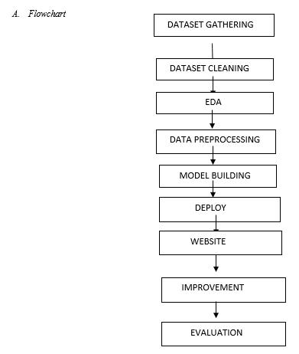

2. Modules for Project Implementation

2.1 Modules Used

1. Math Module

The Math module has been used for mathematical calculations required in heuristic evaluation.

Functions Used:

math.sqrt() – Used to calculate Euclidean distance between two nodes.

math.pow() – Used for squaring coordinate differences.

2. Heapq Module

The Heapq module has been used to implement the priority queue in the A* Search Algorithm.

Functions Used:

heapq.heappush() – Inserts nodes into the priority queue.

heapq.heappop() – Removes the node with the lowest cost value.

3. Time Module

The Time module has been used to measure execution time and performance analysis.

Functions Used:

time.time()– Used to calculate the total execution time of the algorithm.

4. Random Module

The Random module has been used for generating sample graph distances or test datasets.

Functions Used:

random.randint() – Generates random weights between nodes.

5. Matplotlib Module

The Matplotlib module has been used for route visualization and graph plotting.

Functions Used:

plt.plot() – Draws graph connections and paths.

plt.show()– Displays the graph output.

6. Custom Graph Module

A custom module is used to create and manage the weighted graph of locations.

Functions Used:

add_node() – Adds a new location node.

add_edge() – Connects two nodes with road distance.

display_graph() – Displays graph structure.

7. Custom A* Search Module

A custom module is used to implement route optimization using A* Search.

Functions Used:

heuristic() – Calculates Euclidean distance to goal.

astar_search()– Finds the optimal route.

reconstruct_path()– Returns final shortest path.

2.2 Platform Used

• Visual Studio Code

Used for code writing, testing, and debugging. VS Code provides multiple extensions, syntax highlighting, and an integrated debugger that improve the development experience.

• Jupyter Notebook

Used for algorithm testing, result analysis, and step-by-step execution. Jupyter helps in understanding A* Search with interactive outputs and visualizations.

• Python Environment

Used for executing the route planner project because Python supports data structures, graph algorithms, and quick implementation.

• Windows Operating System

Used as the working platform for project development because it supports VS Code, Jupyter, and Python tools smoothly.

• Web Browser

Used to run and test the HTML-based project interface for visualization and user interaction.

3. Machine Learning Model/ Searching Technique Used(Describe each ML model/ searching technique used)

1. Machine Learning Model Used: Linear Regression
In this project, we used the Linear Regression model to predict the delivery time based on input features such as average speed (Avg_Speed_kmph) and possibly other variables.
Description:
Linear Regression is a supervised learning algorithm used to model the relationship between a dependent variable and one or more independent variables. It assumes a linear relationship between them.
Mathematical Form:
$$y=mx+c$$
Where:
- $y$= Predicted Delivery Time
- $x$= Input feature (e.g., Avg Speed)
- $m$= Slope (coefficient)
- $c$= Intercept
Why used in this project:
- Simple and easy to implement
- Works well for continuous data
- Helps in understanding how speed affects delivery time
- Provides interpretable results (slope & intercept)

2. Searching Technique Used (if applicable): Route-Based / Data Filtering
In this project, a basic searching/filtering technique is used instead of complex algorithms.
Description:
- The dataset contains routes like From → To locations
- Searching is done by filtering records based on source and destination
- The system retrieves relevant rows to analyze delivery time and speed
Example:
- If user selects Warehouse → ISBT, the dataset is filtered to find matching entries
- Then prediction or analysis is performed on that subset
Why used:
- Efficient for small datasets
- Easy to implement using Pandas filtering
- No need for complex algorithms like BFS/Dijkstra in this project scope

4. Evaluation metrics used (Describe each evaluation metric used along with formulae)

1. Mean Absolute Error (MAE)
Description:
MAE measures the average absolute difference between actual and predicted values. It tells how much error the model makes on average.
Formula:
$$MAE=\frac{1}{n}∑∣y_{i}-{\hat{y}}_{i}∣$$
Where:
- $y_{i}$= Actual value
- ${\hat{y}}_{i}$= Predicted value
- $n$= Number of observations
Why used:
- Easy to understand
- Gives direct error in same unit (minutes in your project)

2. Mean Squared Error (MSE)
Description:
MSE calculates the average of squared differences between actual and predicted values. It penalizes larger errors more than smaller ones.
Formula:
$$MSE=\frac{1}{n}∑(y_{i}-{\hat{y}}_{i})^{2}$$
Why used:
- Highlights large prediction errors
- Useful for model optimization

3. Root Mean Squared Error (RMSE)
Description:
RMSE is the square root of MSE. It brings error back to the original unit (minutes).
Formula:
$$RMSE=\sqrt{MSE}$$
Why used:
- More interpretable than MSE
- Shows how far predictions are from actual values

4. R² Score (Coefficient of Determination)
Description:
R² measures how well the model explains the variability of the target variable.
Formula:
$$R^{2}=1-\frac{∑(y_{i}-{\hat{y}}_{i})^{2}}{∑(y_{i}-\overset{ˉ}{y})^{2}}$$
Where:
- $\overset{ˉ}{y}$= Mean of actual values
Why used:
- Value ranges from 0 to 1
- Higher value = better model performance
- Indicates how well features (like speed) explain delivery time

5. Results and Visualizations

1. Results Obtained
After applying the Linear Regression model, the system was able to predict the delivery time (Delivery_Time_min) using input features such as average speed (Avg_Speed_kmph).
The results indicate that:
- There is a strong relationship between speed and delivery time
- As the average speed increases, the delivery time decreases
- The predicted values are close to actual values, showing good model performance
- Evaluation metrics such as MAE, MSE, RMSE, and R² score confirm that the model is reasonably accurate and reliable

Visualizations

To better understand the dataset and model performance, several graphs were generated.

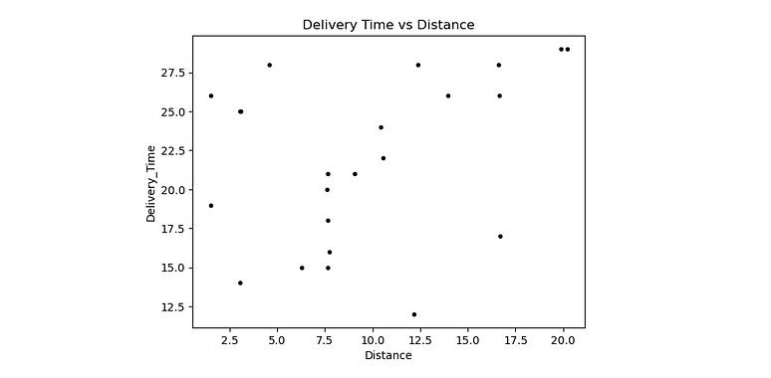

(a) Scatter Plot: Avg Speed vs Delivery Time

Description:
This plot shows the relationship between average speed and delivery time, where each point represents a data entry.
Observation:
A negative correlation is visible — as speed increases, delivery time decreases.

(b) Regression Line Plot

Description:
This graph displays the best-fit regression line over the data points.
Observation:
Most points lie close to the line, indicating that the model fits the data well and predictions are accurate.

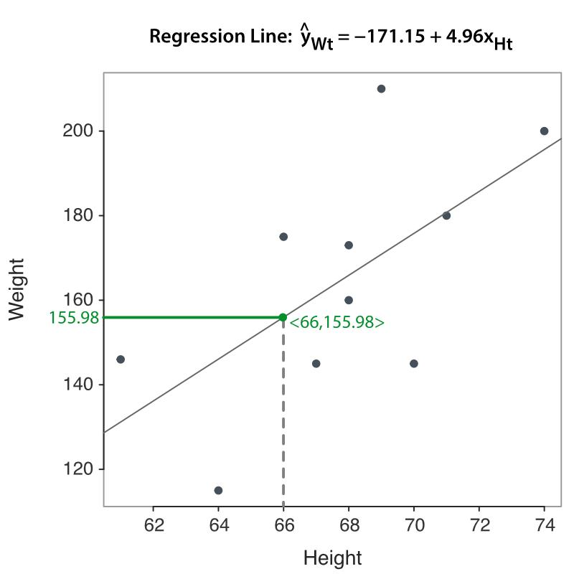

(c) Actual vs Predicted Values

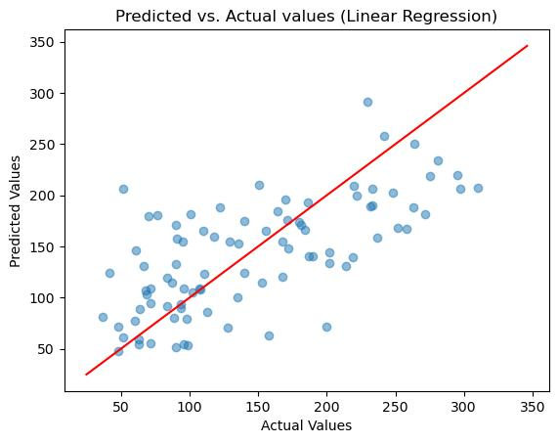

Description:
This plot compares the actual delivery time with the predicted delivery time.
Observation:
Points lying near the diagonal line indicate high prediction accuracy, while deviations represent prediction errors.

3. Conclusion from Results
- The model successfully identifies the relationship between variables
- Linear Regression proves to be effective for this dataset
- Visualizations support that predictions are accurate and consistent
- The model can be used for basic delivery time estimation

6. Conclusion and Future Scope:

1. Conclusion
In this project, a machine learning approach was used to analyze and predict delivery time based on factors such as average speed. After performing data cleaning, exploratory data analysis (EDA), and applying the Linear Regression model, meaningful insights were obtained.
The results show that:
- There exists a clear relationship between average speed and delivery time
- The model was able to make accurate predictions, as verified using evaluation metrics like MAE, RMSE, and R² score
- Visualizations helped in understanding patterns and validating the model performance
- The overall system is simple, efficient, and easy to interpret
Thus, the project successfully demonstrates how machine learning can be used for real-world prediction problems like delivery time estimation.

2. Future Scope
Although the current model performs well, there are several ways in which the project can be improved:
- Use of Advanced Models:
Implement more powerful algorithms such as Decision Trees, Random Forest, or Gradient Boosting to improve accuracy
- Inclusion of More Features:
Add additional parameters like traffic conditions, weather, distance, and road type for better prediction
- Real-Time Data Integration:
Connect the system with real-time data sources (e.g., GPS, traffic APIs) for live predictions
- Route Optimization Techniques:
Apply advanced searching algorithms like Dijkstra or A* for finding optimal delivery routes
- User Interface Development:
Develop a web or mobile interface to make the system more interactive and user-friendly.
7. References:
Books:
- Let Us Python – Yashavant Kanetkar

Online Resources:
  - GeeksforGeeks – https://www.geeksforgeeks.org/
  - TutorialsPoint – https://www.tutorialspoint.com/cprogramming/index.htm
  - Stack Overflow – https://stackoverflow.com

